1. Unwanted error message display while click the Get Rate Details button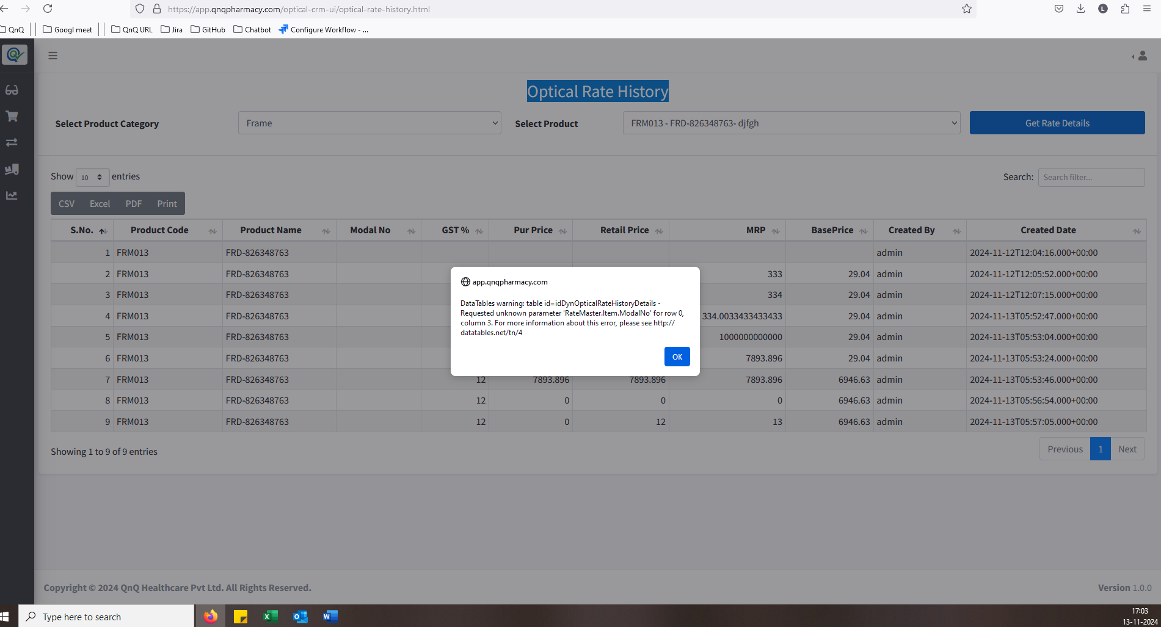//
2. No data message not display in dropdown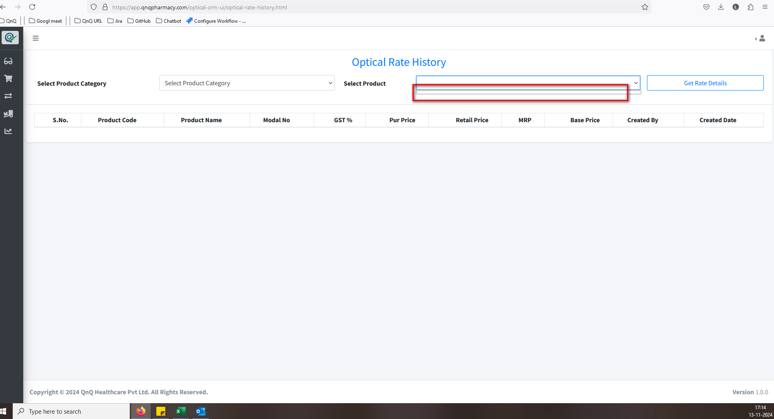//
3. Deleted record display in product dropdown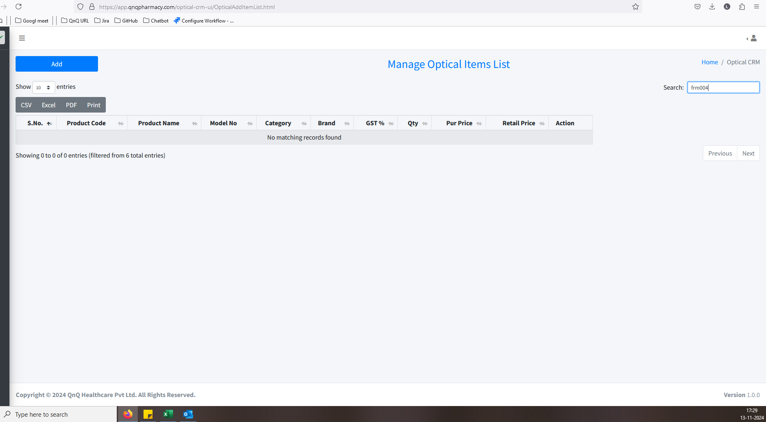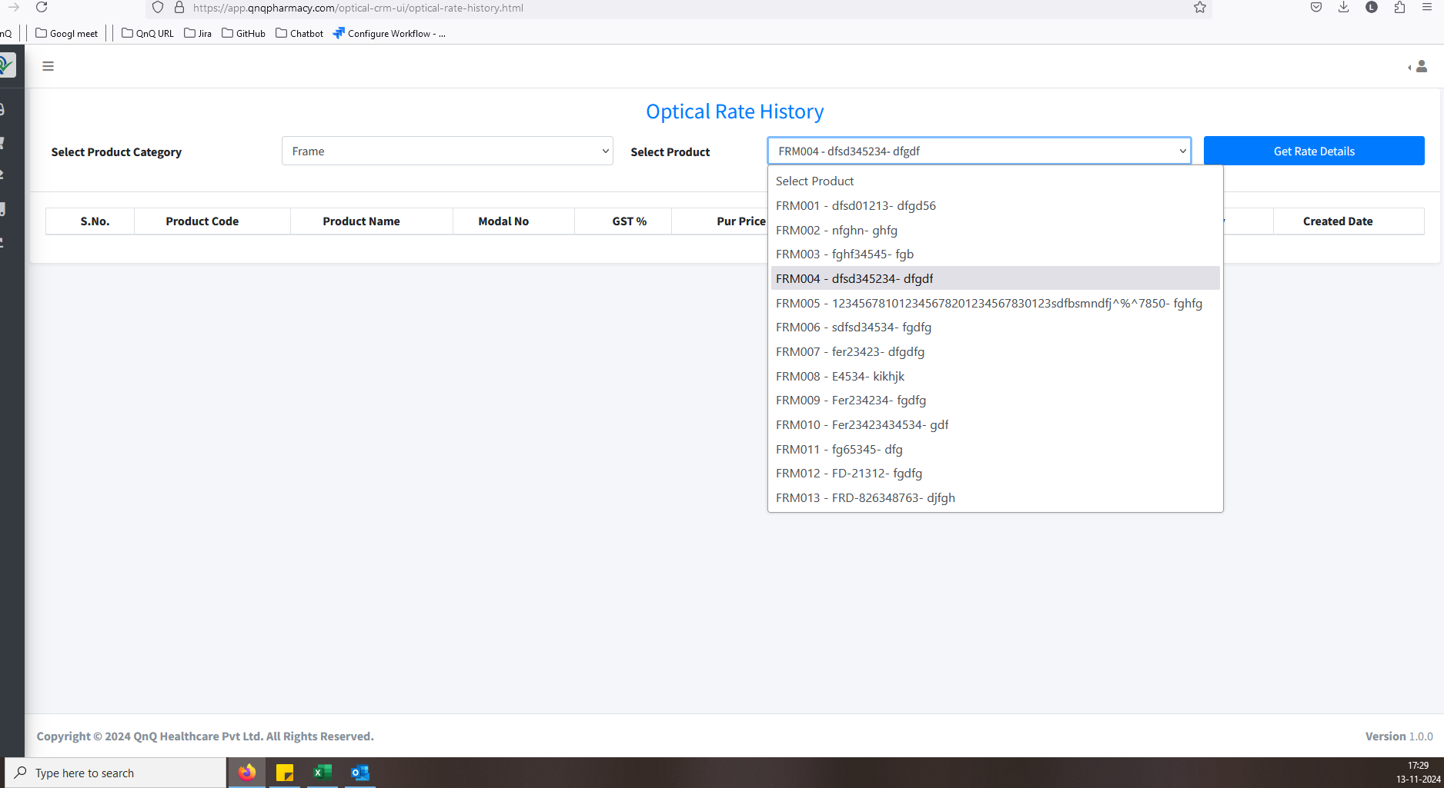//
4. Excessive space is appearing between the label and the field. 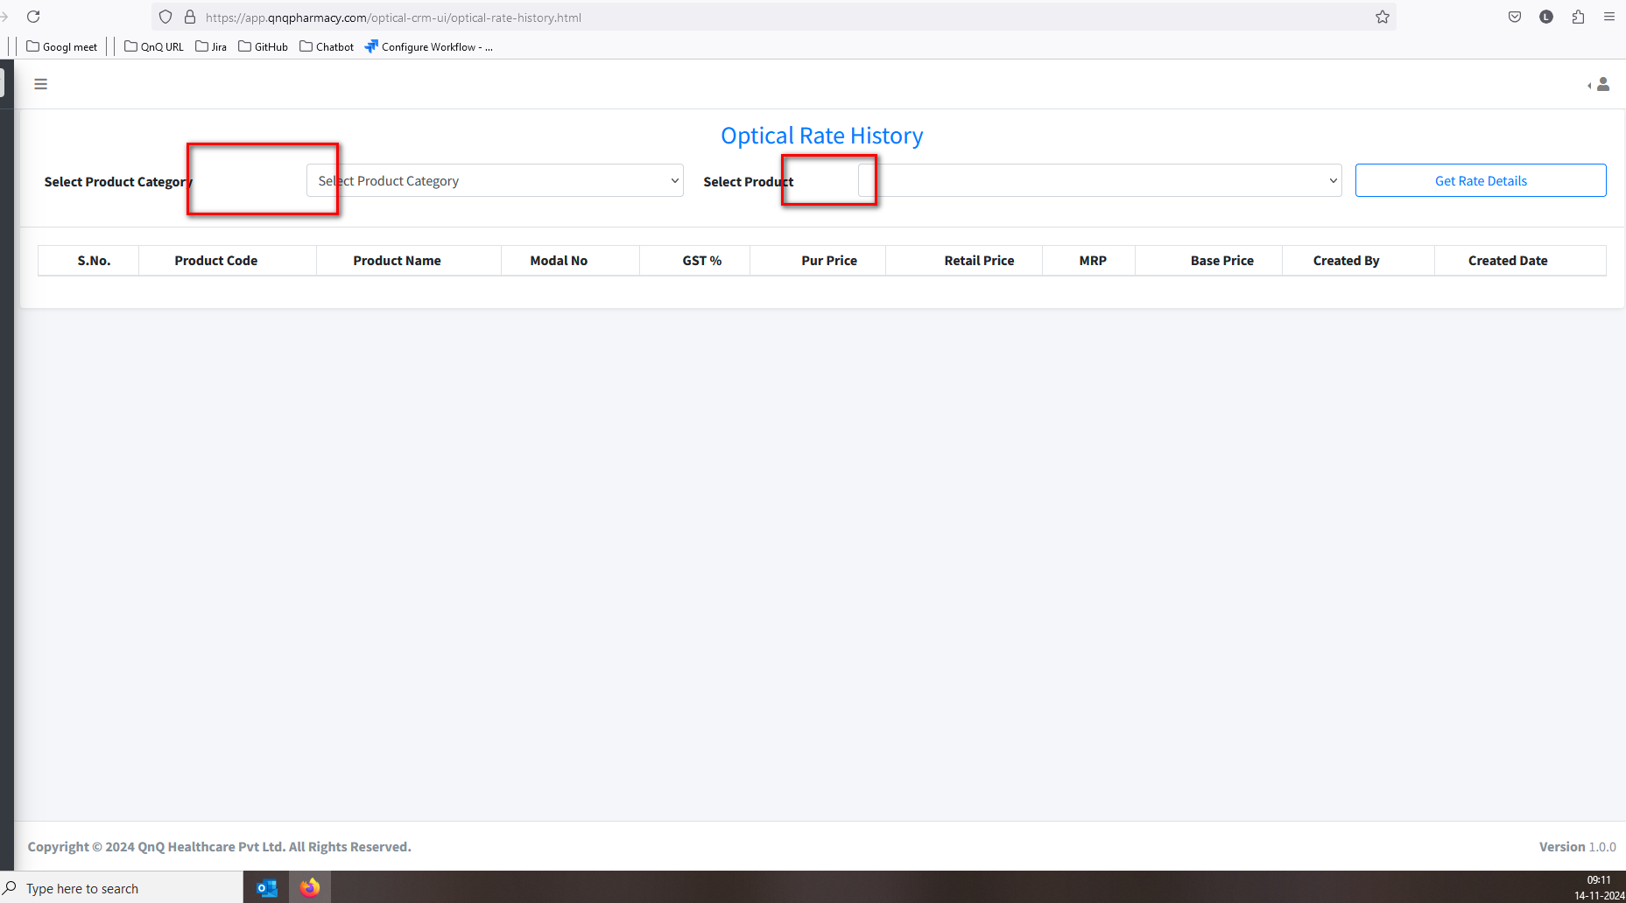//
5. Required error message display while click the Det Rate details button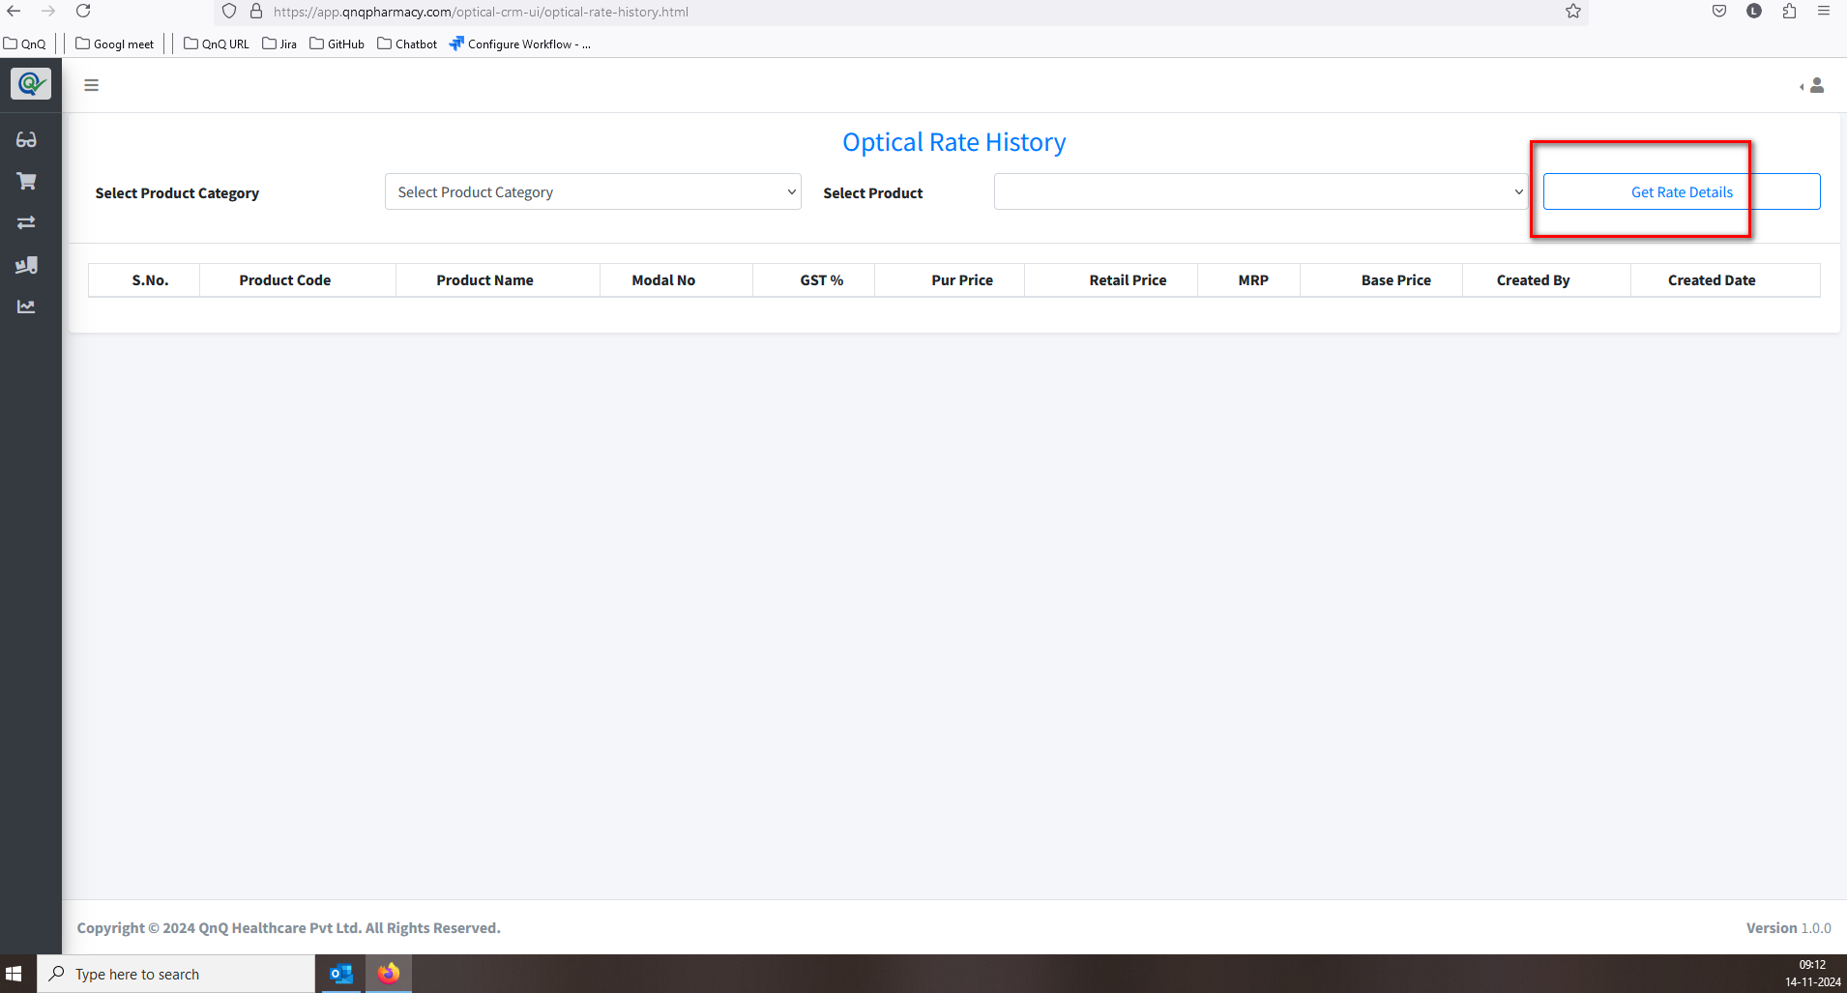//
6. Refresh icon not available for clear the search filter values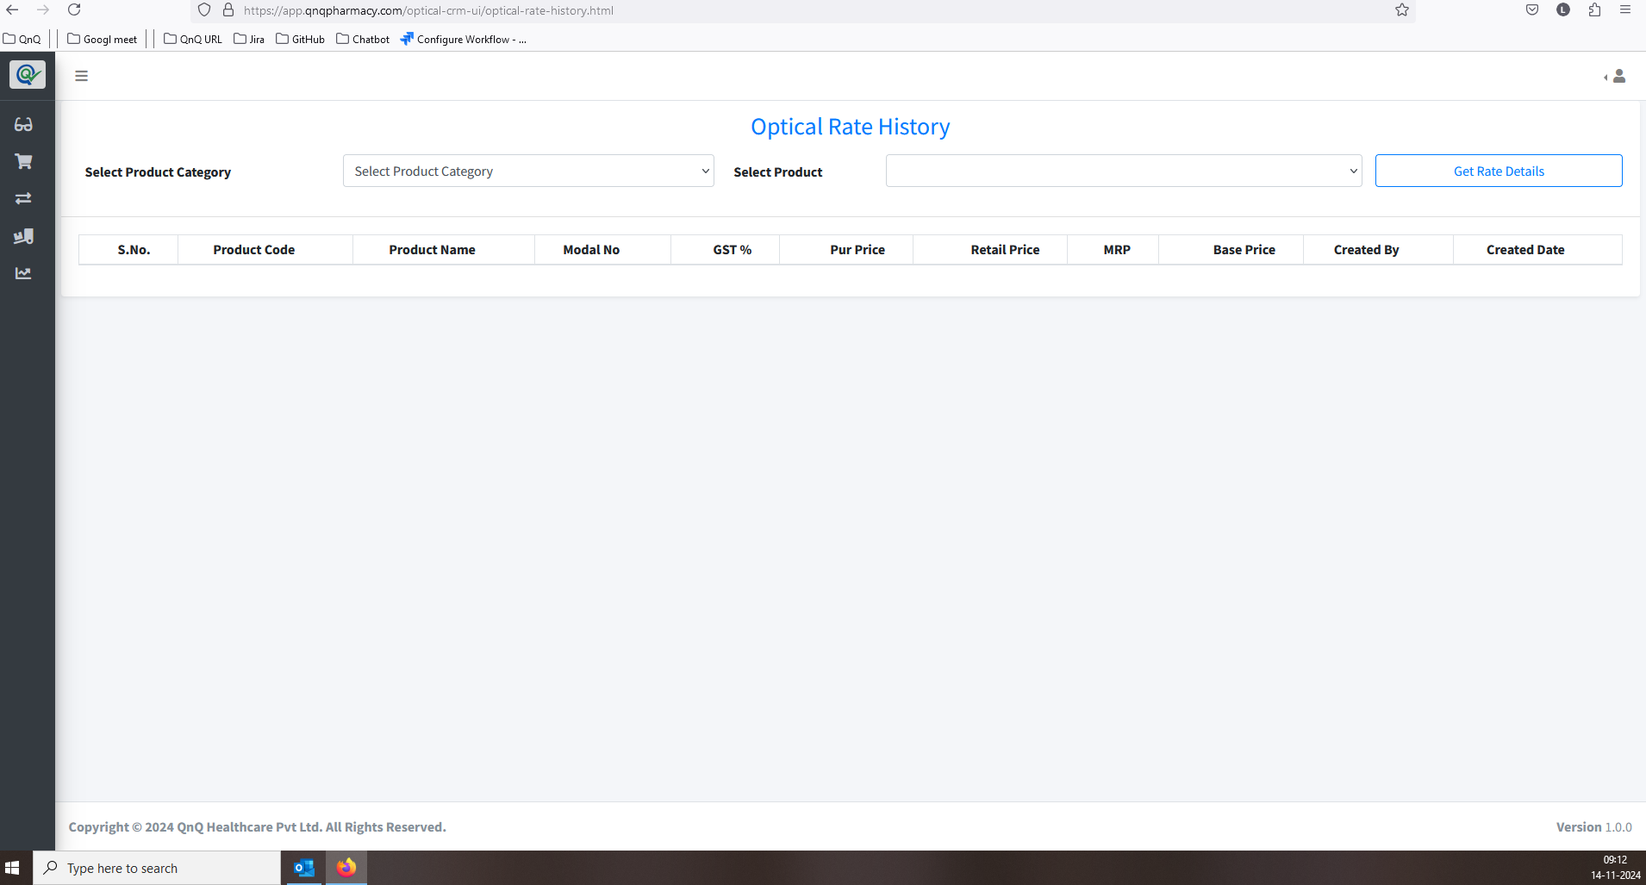//
7. The product value is displayed even when no category is selected 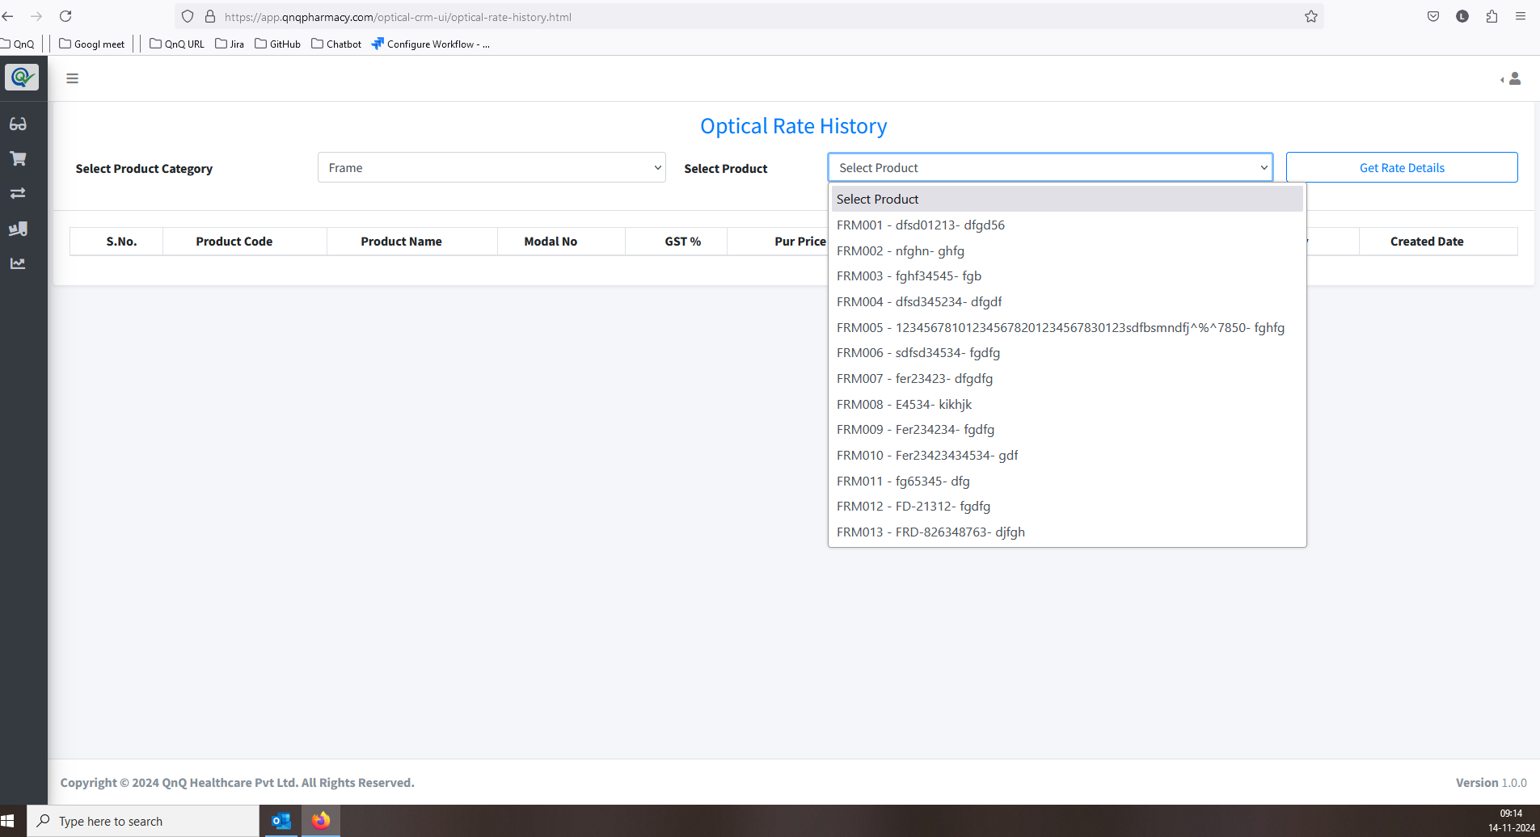//
8. History details display without select the Category value 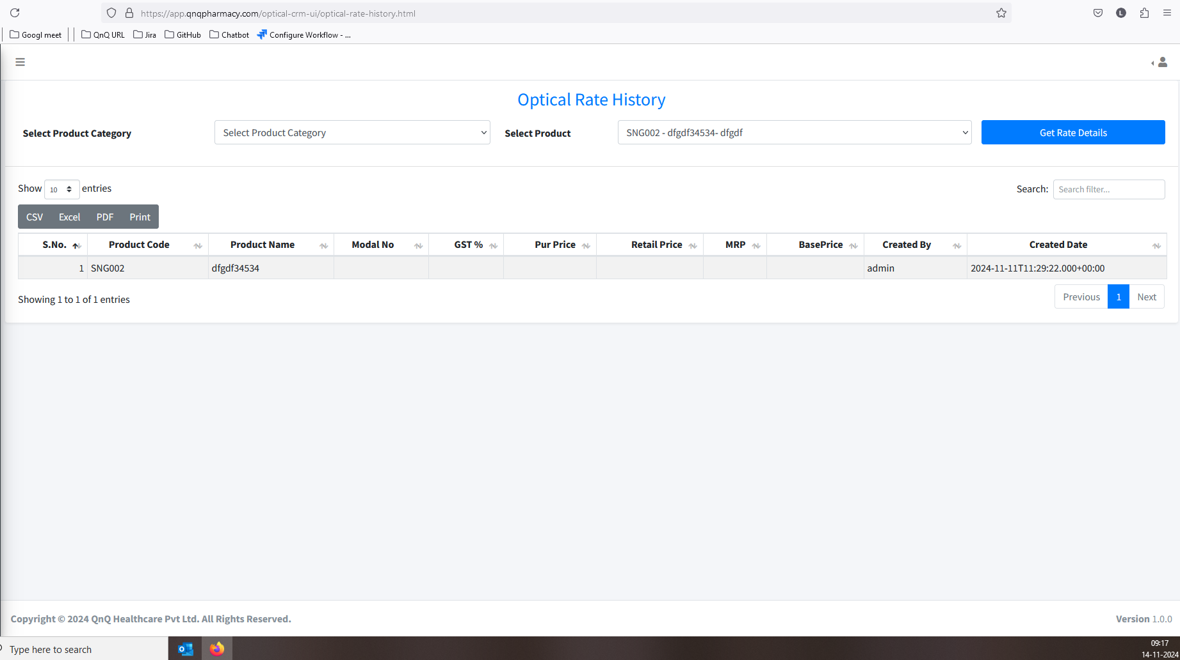 //
9. Error message display while click the Model No. column sort icon  //
10. Download options are displayed even when no values are available in the list grid 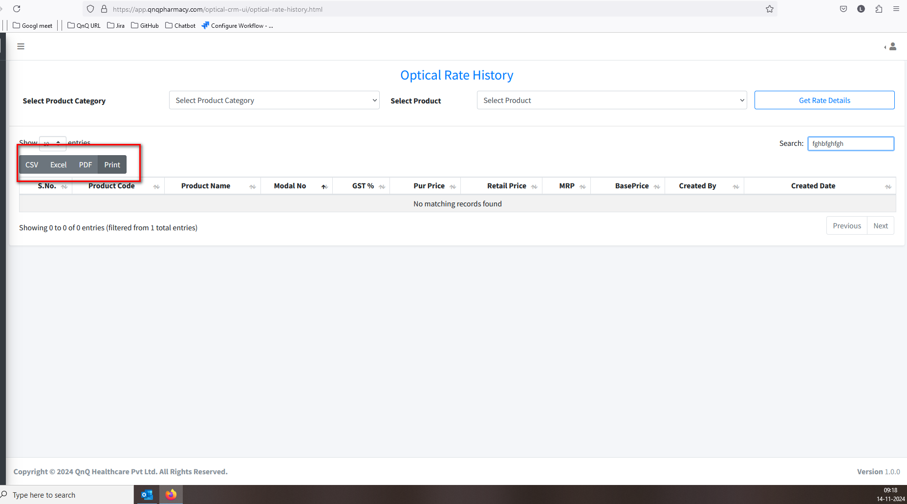 //
11. The history grid displays values after clearing the selected filter 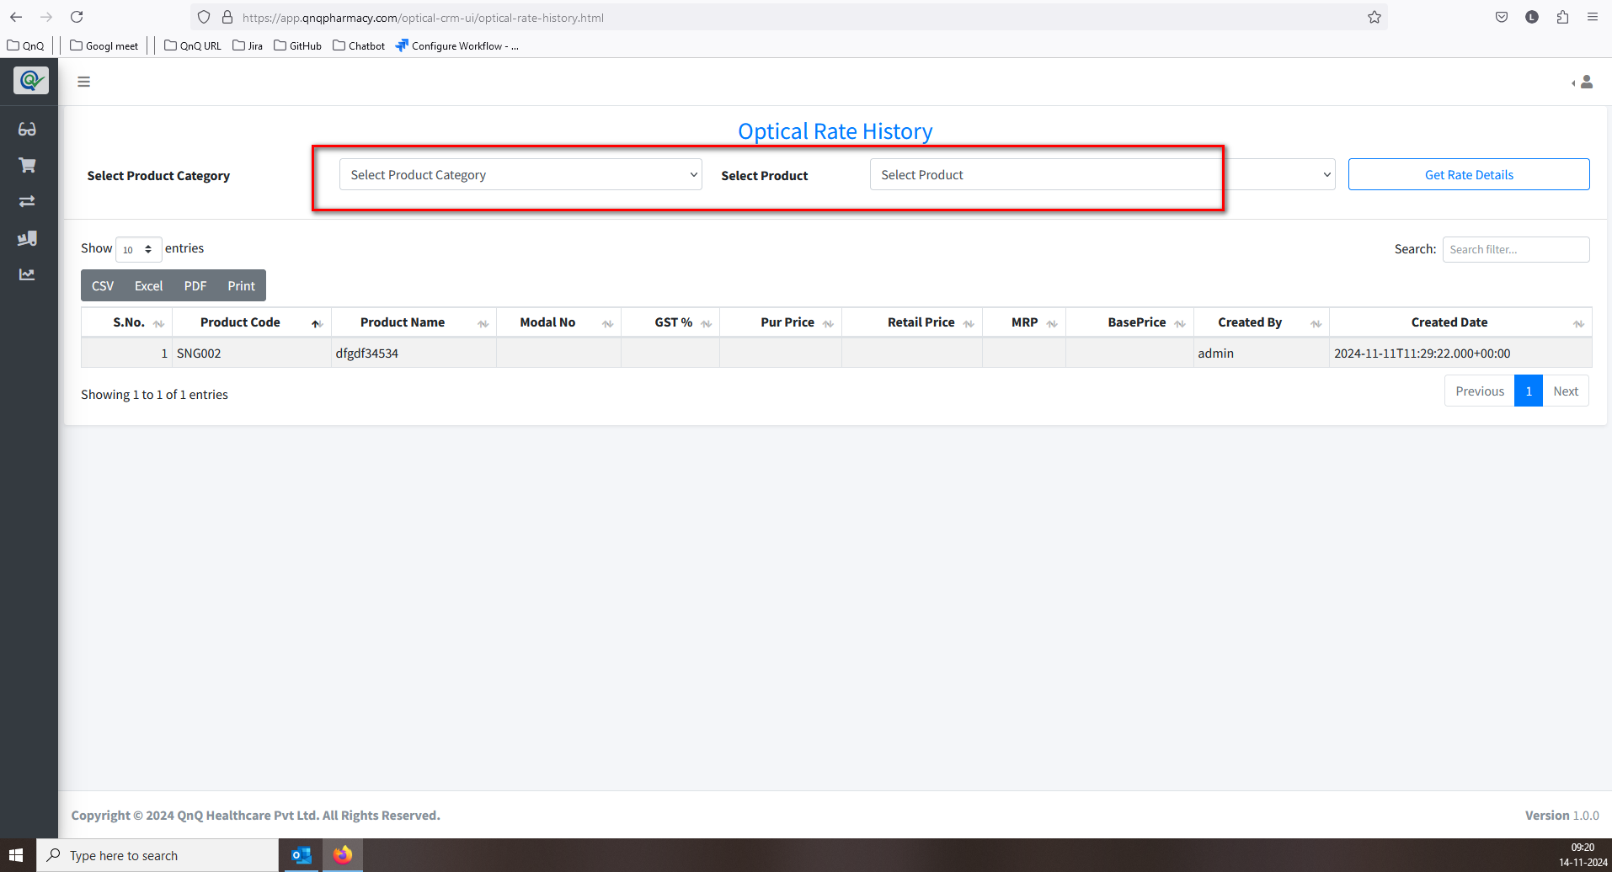 //
12. Model No. value display as empty in History list grid 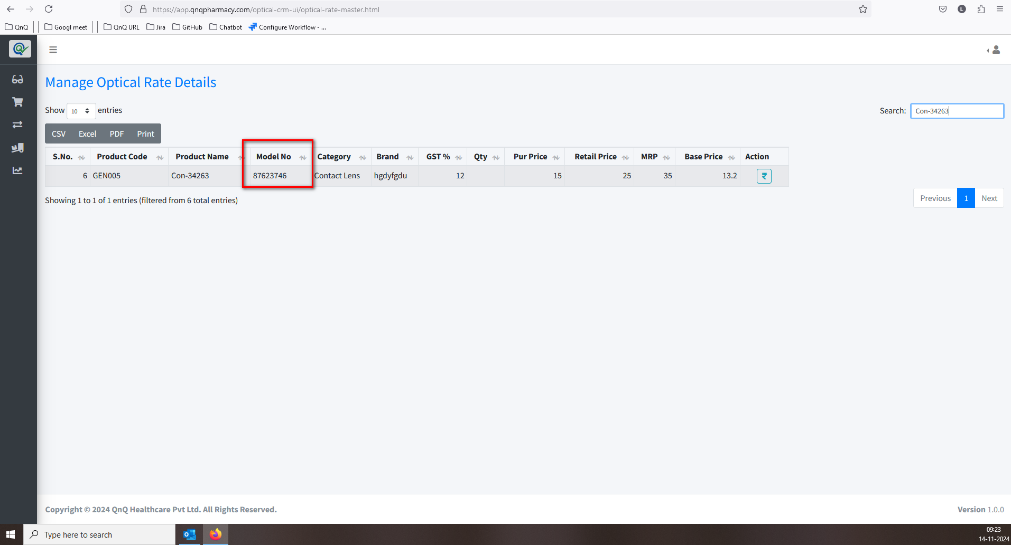 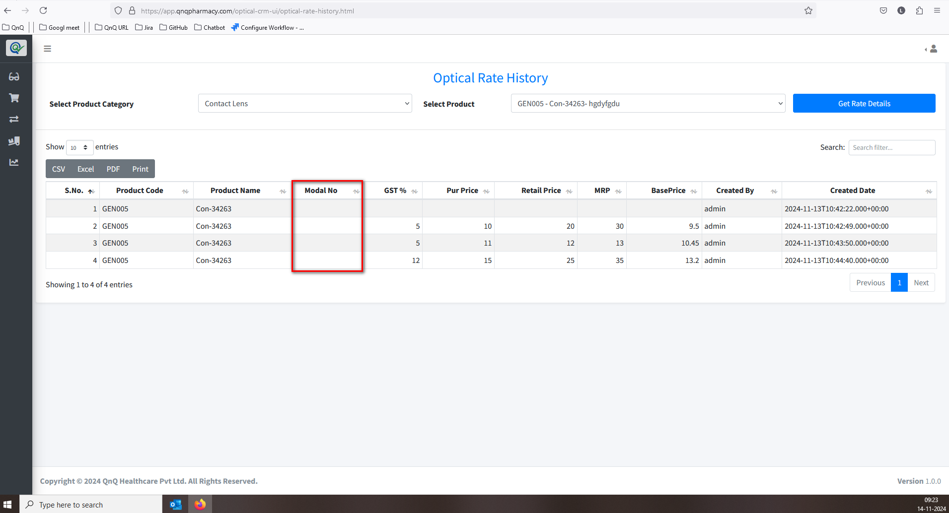 //
13. The history list grid shows lines even when the rate hasn't been updated 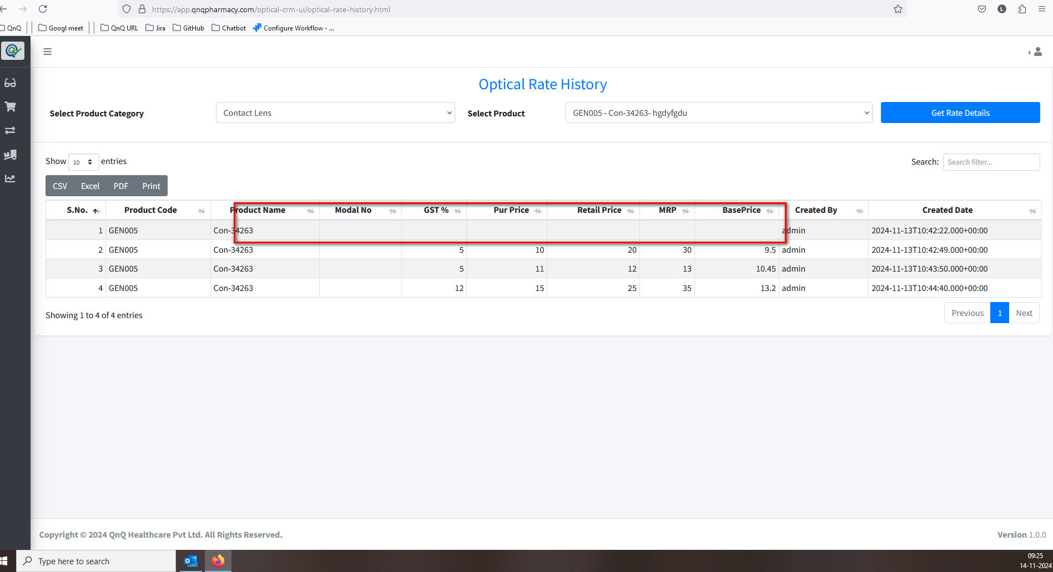 //
14. Mismatch column name display in list grid 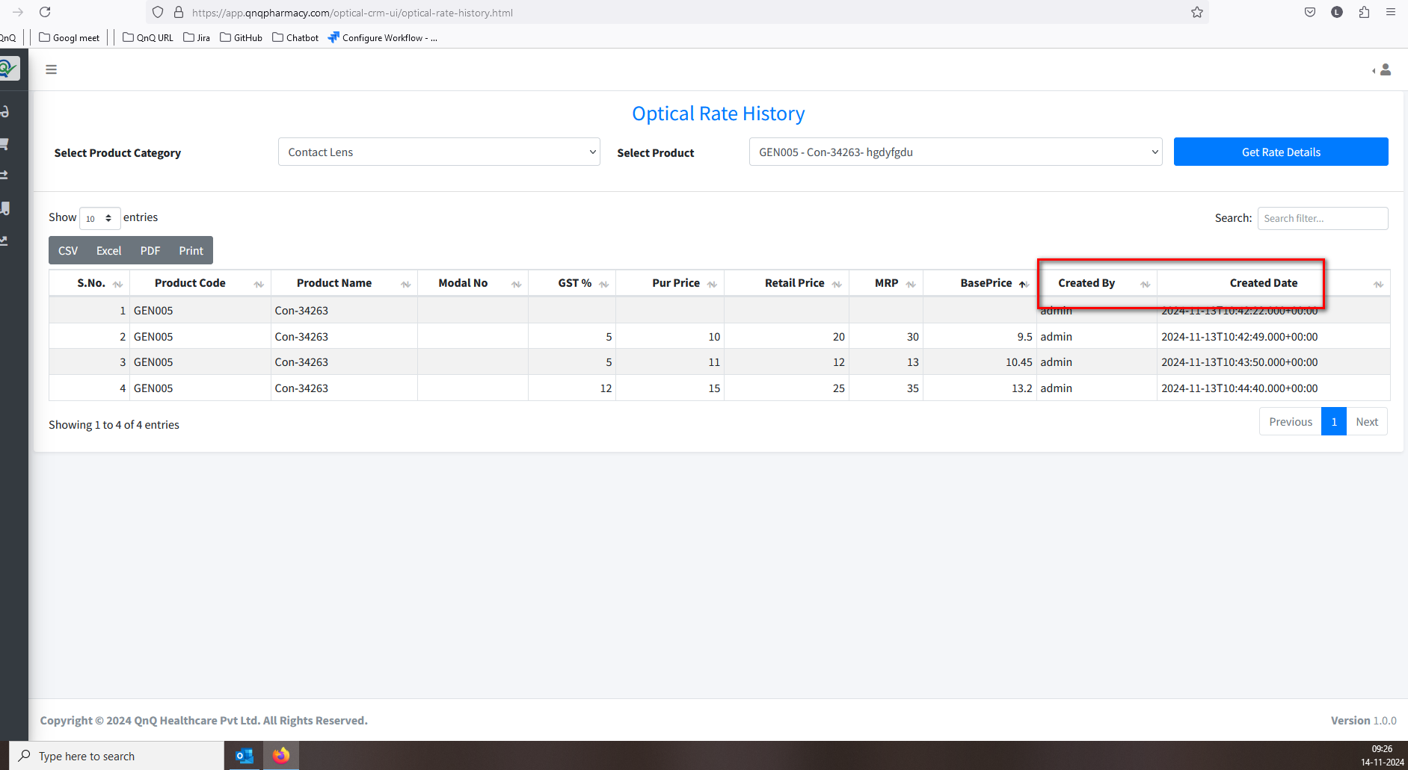 //
15. Unwanted values display in History list grid  //
16. The time value is shown, but the column header isn’t labelled accordingly 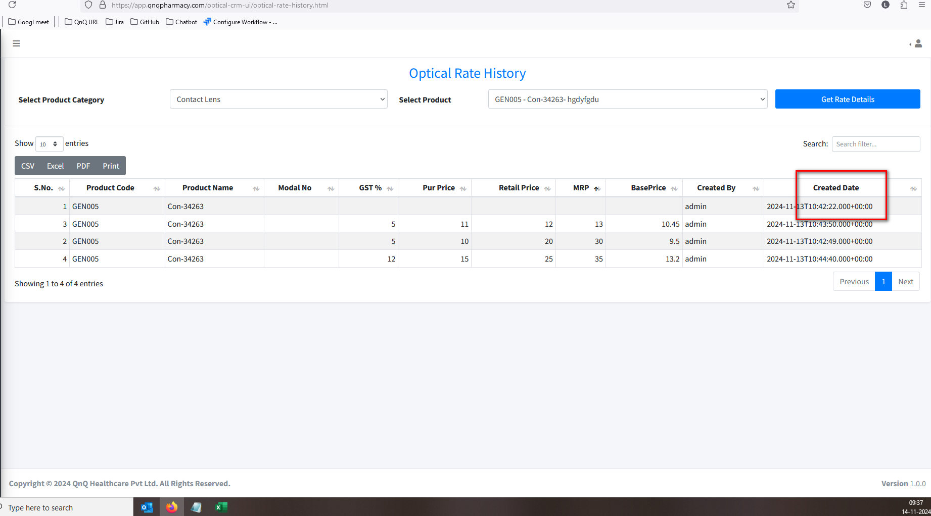 //
17. Column Header, Search filter and Pagination not display 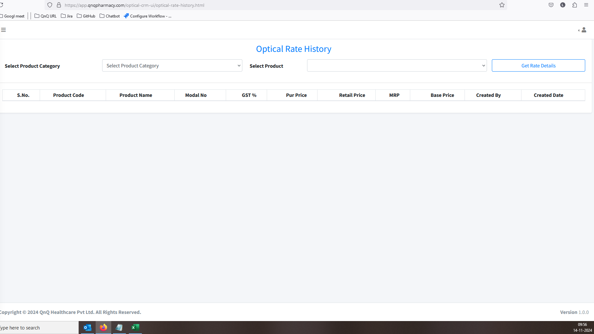 //
18. No record available message not display in list grid  //
19. The navigation suggestion does not appear in the Rate History List grid 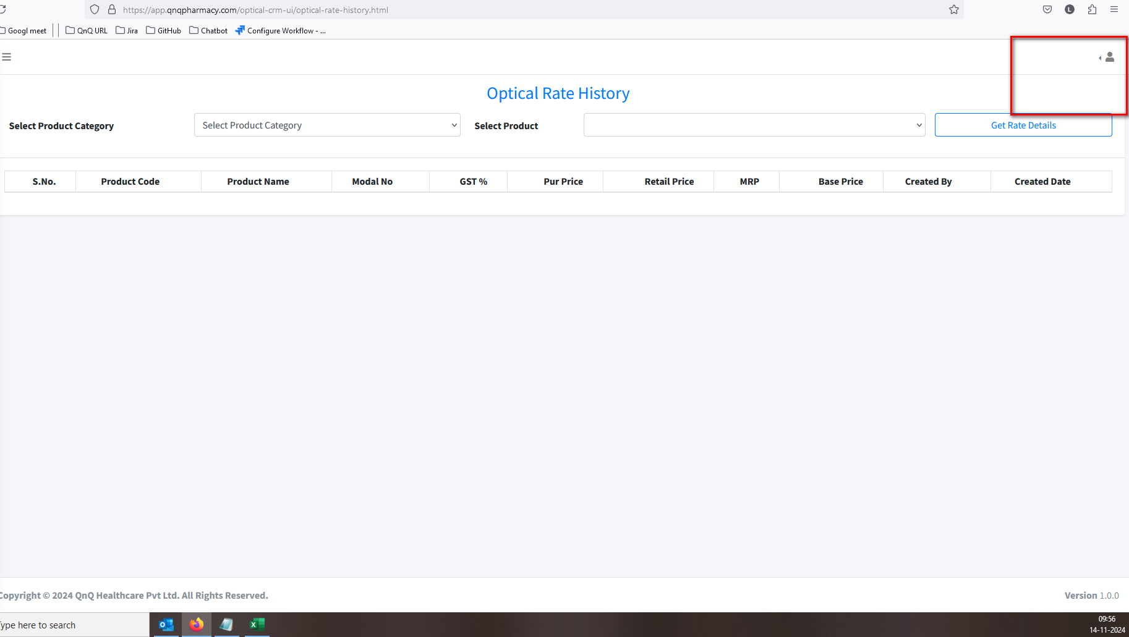 //
20. Unwanted content display in rate values 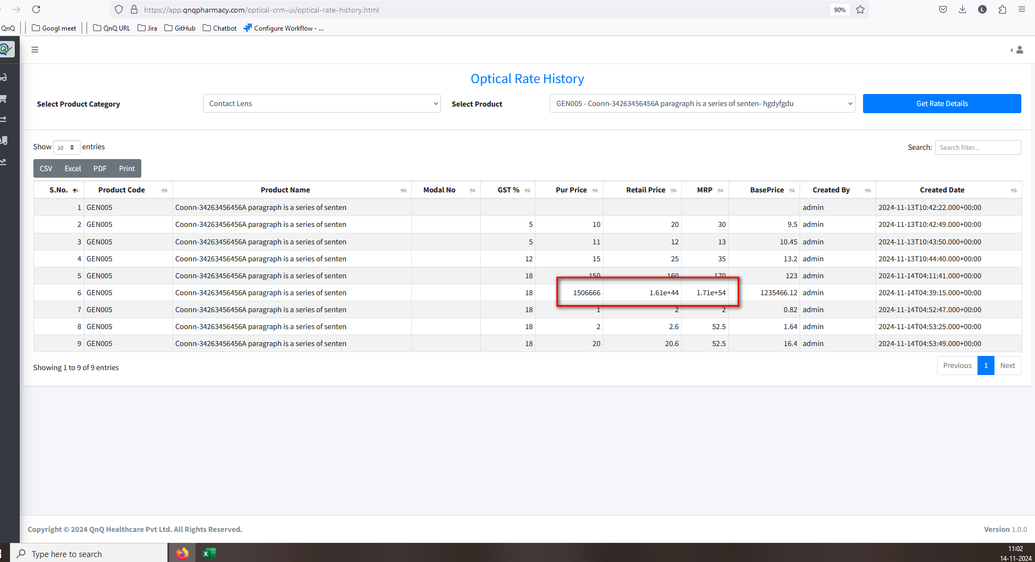 //
21. First letter display as small letter in Showing records content 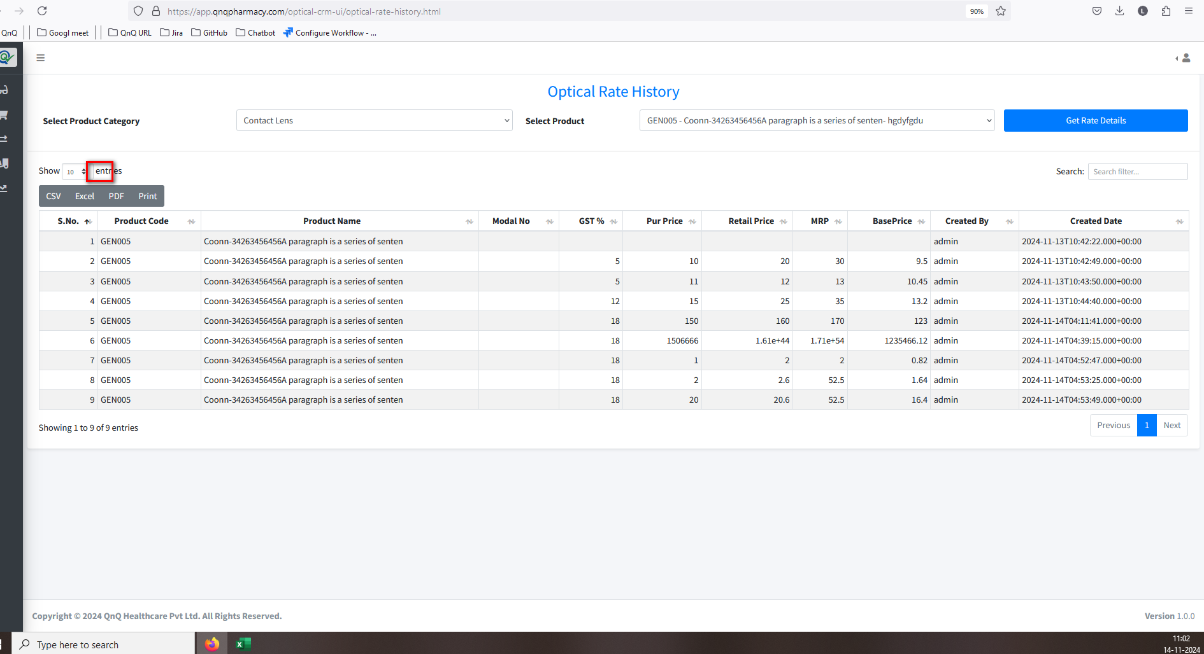 //
22. Unwanted content display in all dropdown 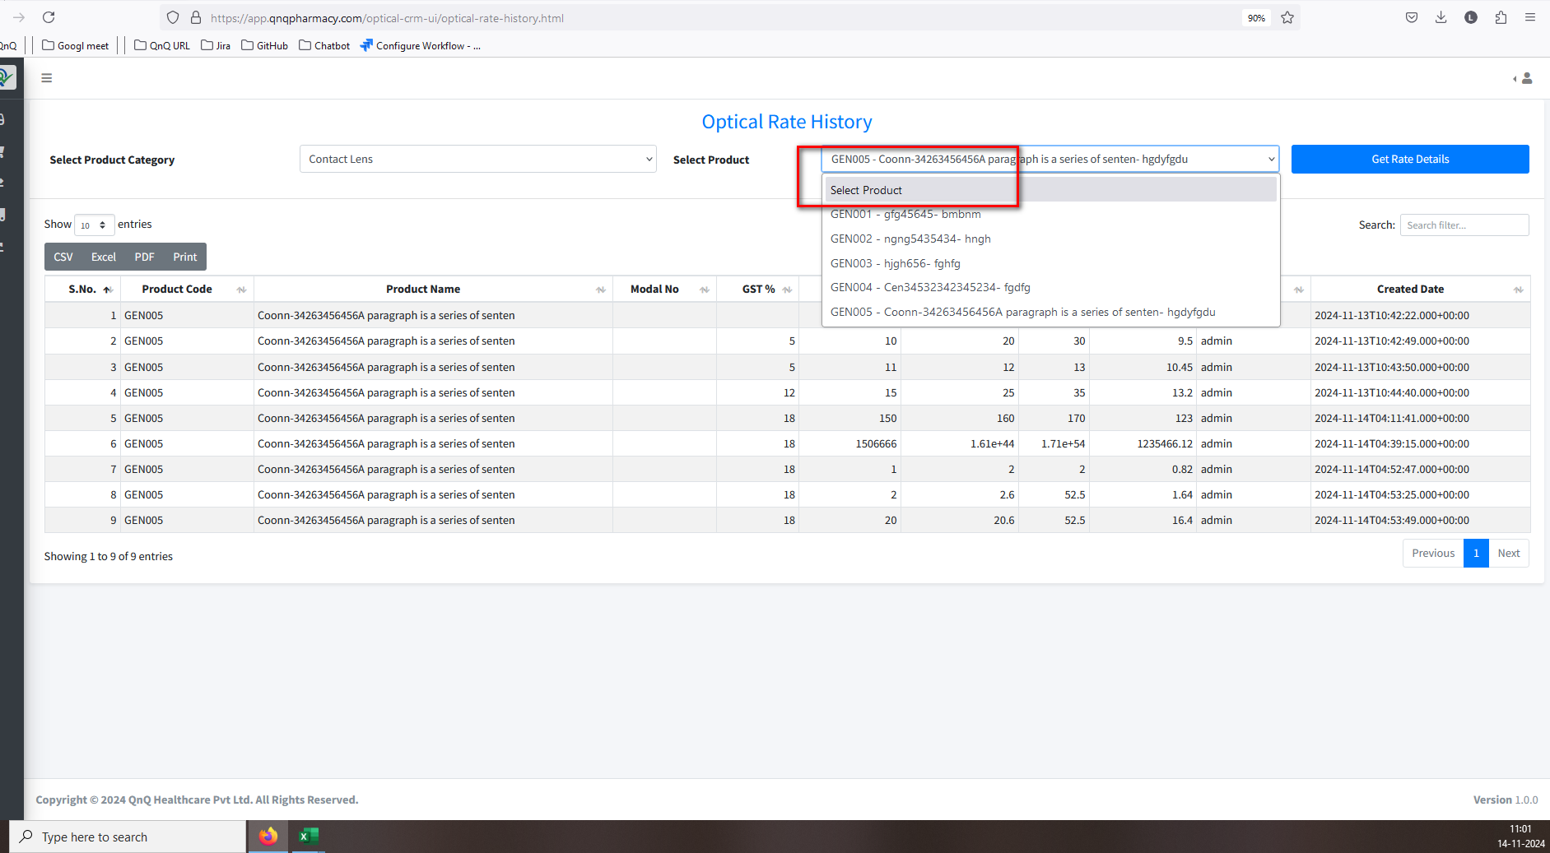 //
23. Unwanted Print button display in list grid 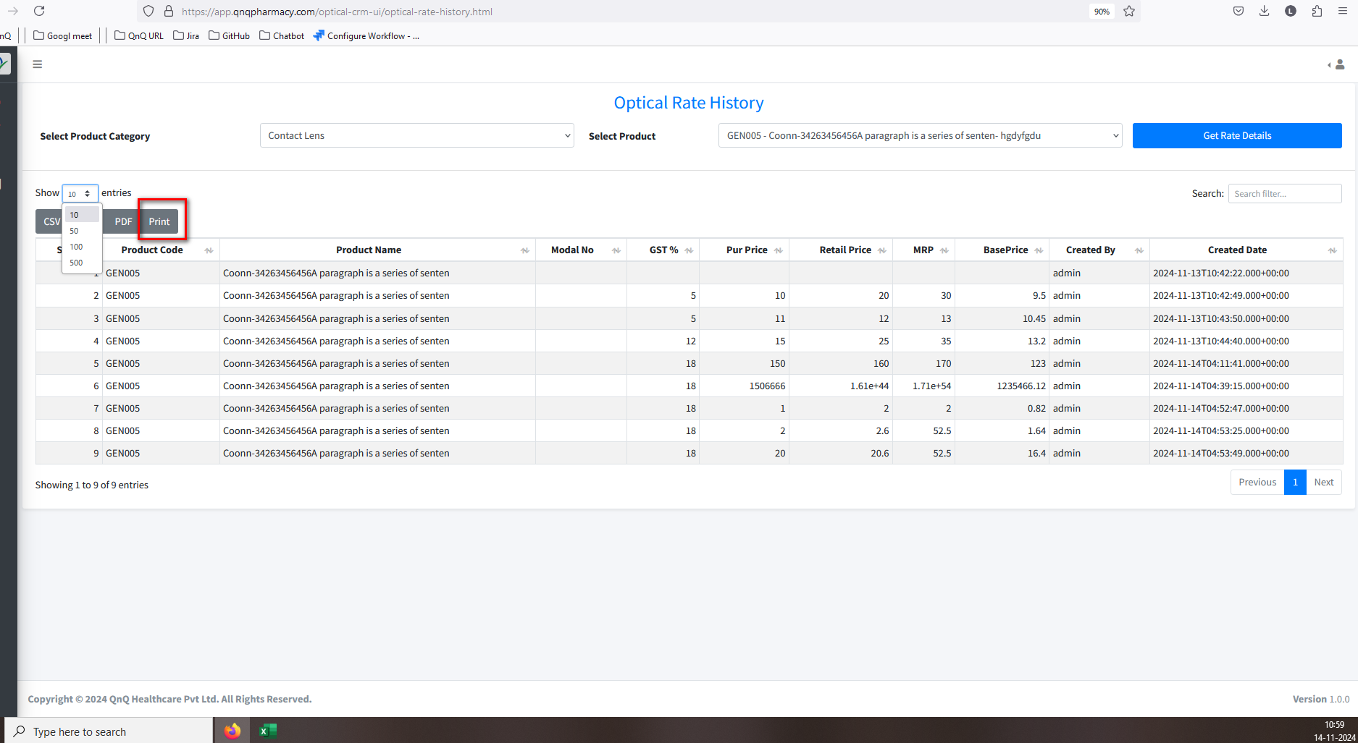 //
24. Mismatch File name display in the download file 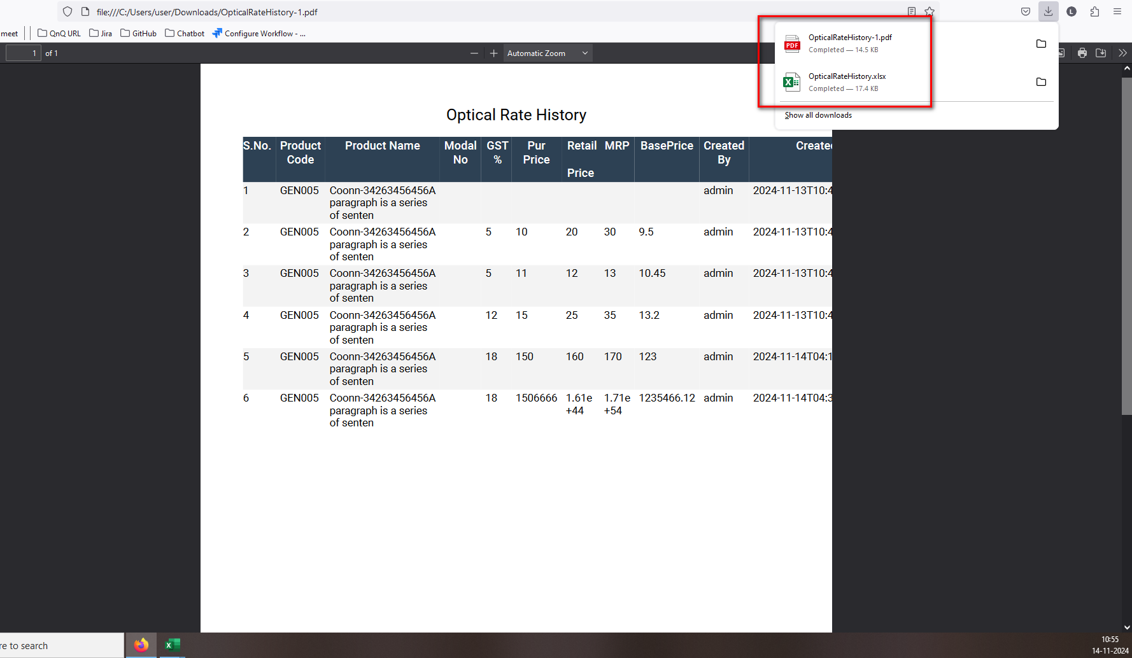 //
25. Unwanted error message display while open the CSV file 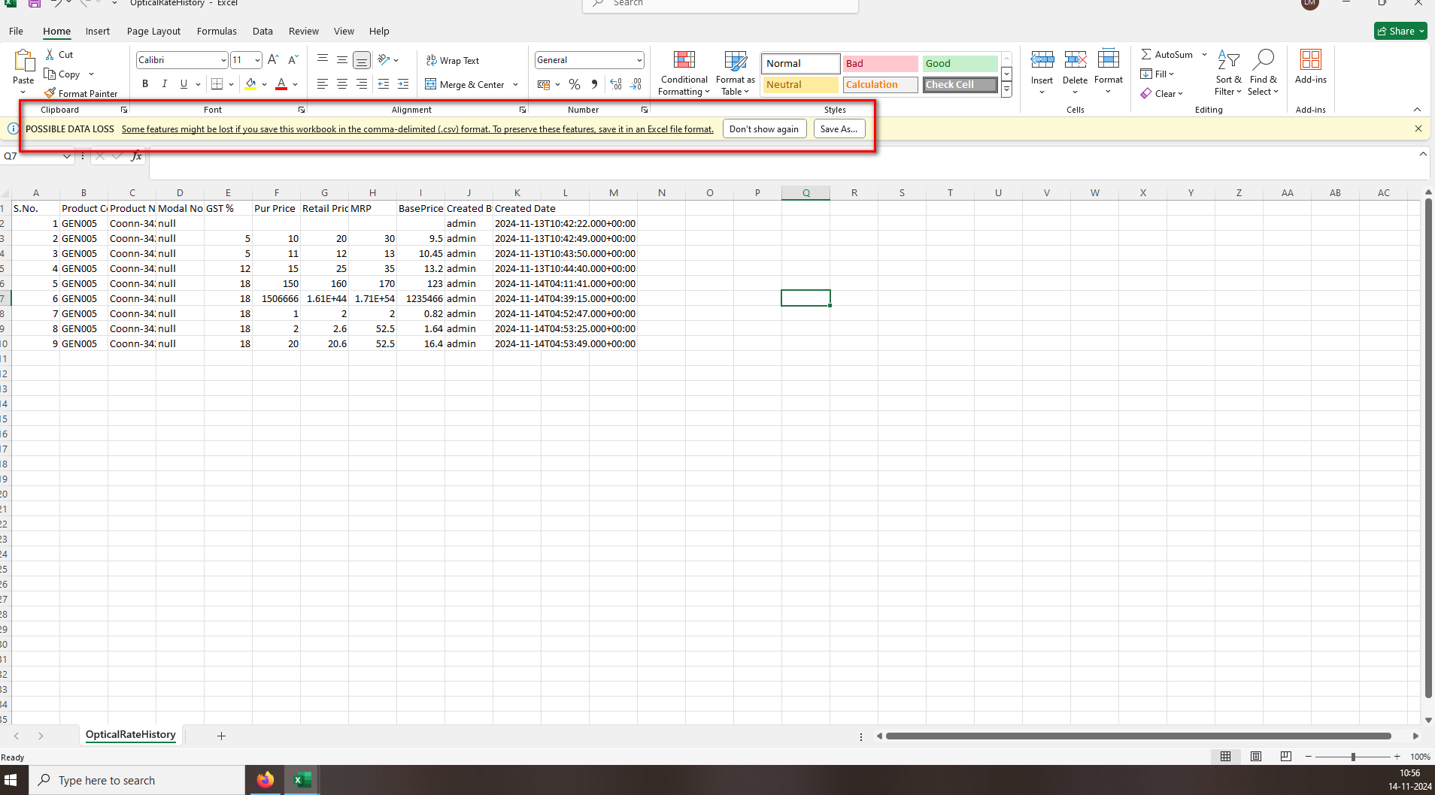 //
26. The column header does not appear like the ad header column in CSV file 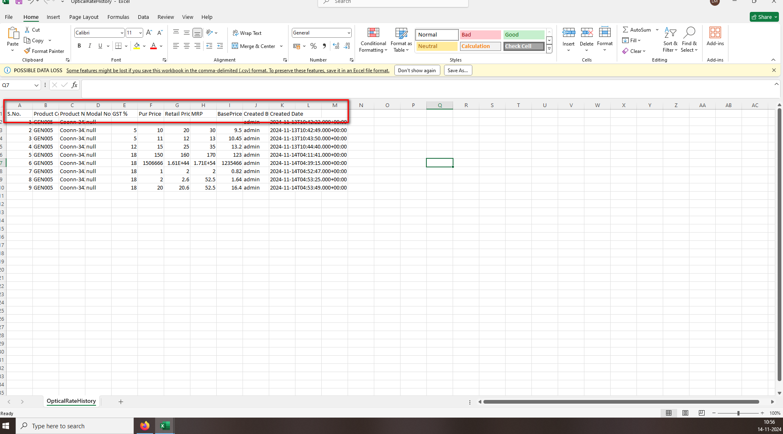 //
27. The sheet name appears without spaces in CSV file 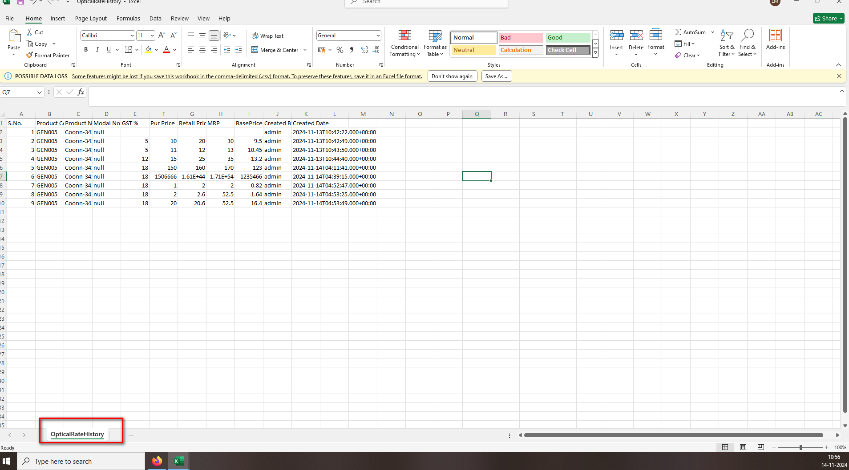 //
28. Document Title not display in Excel file 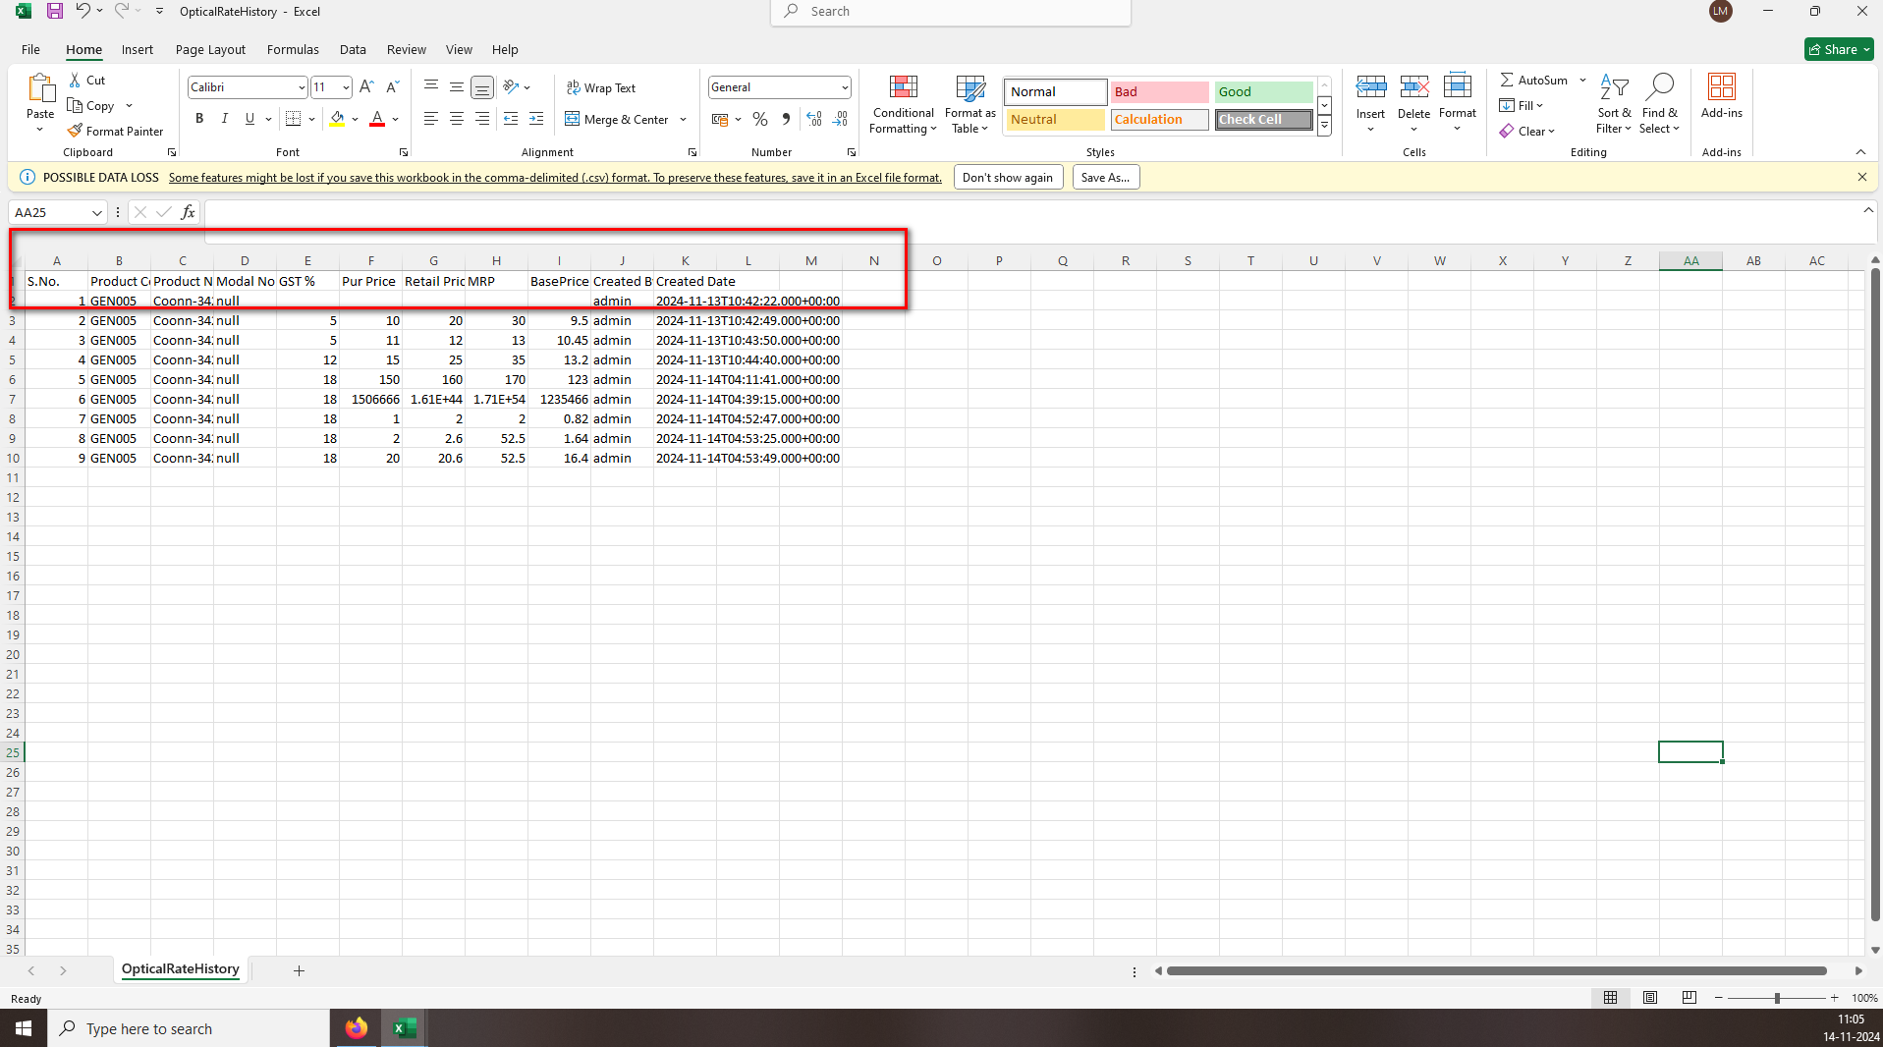 //
29. The data is not displaying correctly; some of it is getting lost 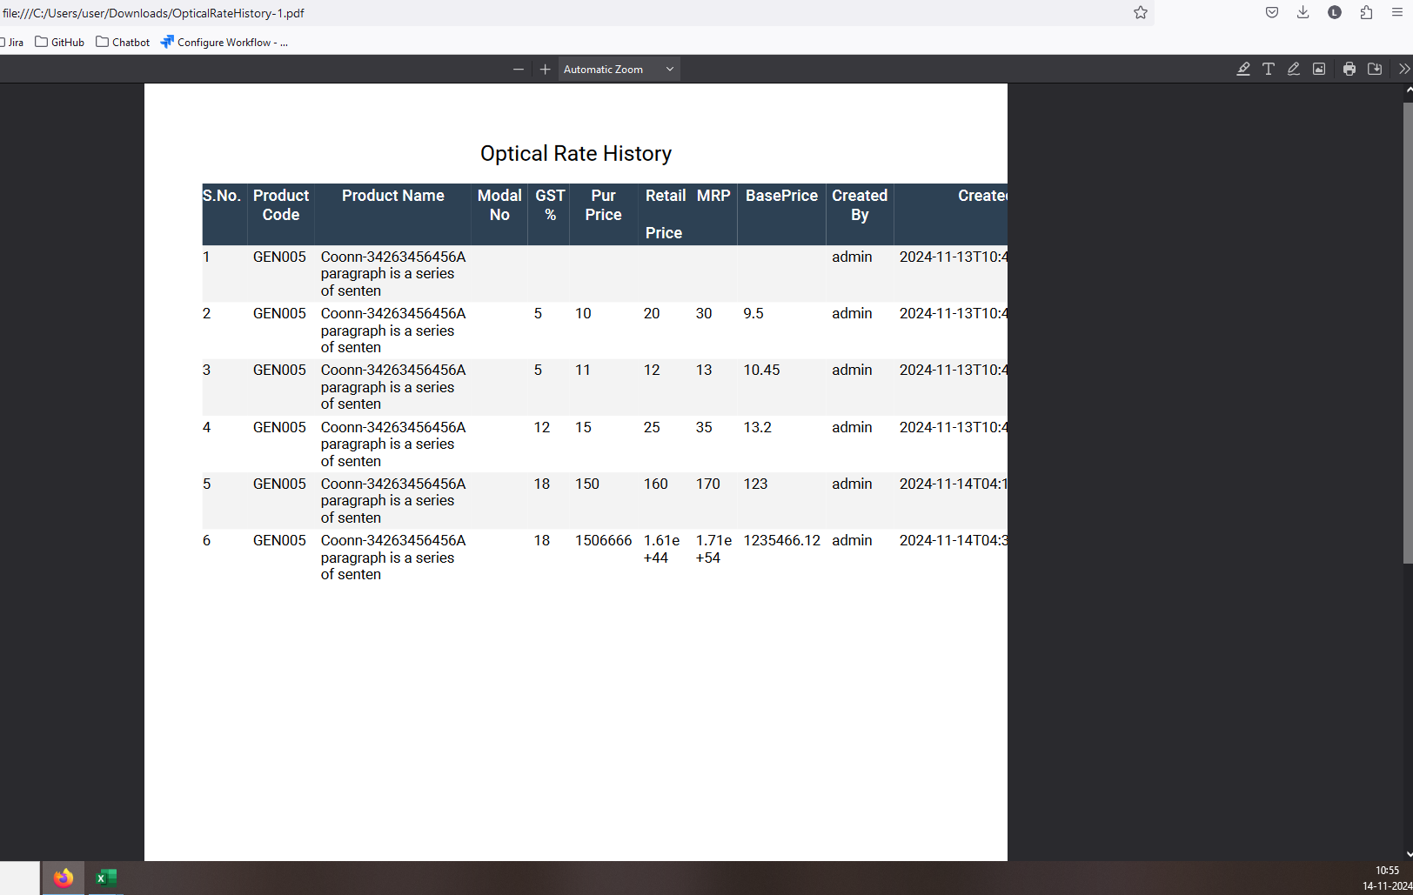 //
30. Sheet name not display in excel file 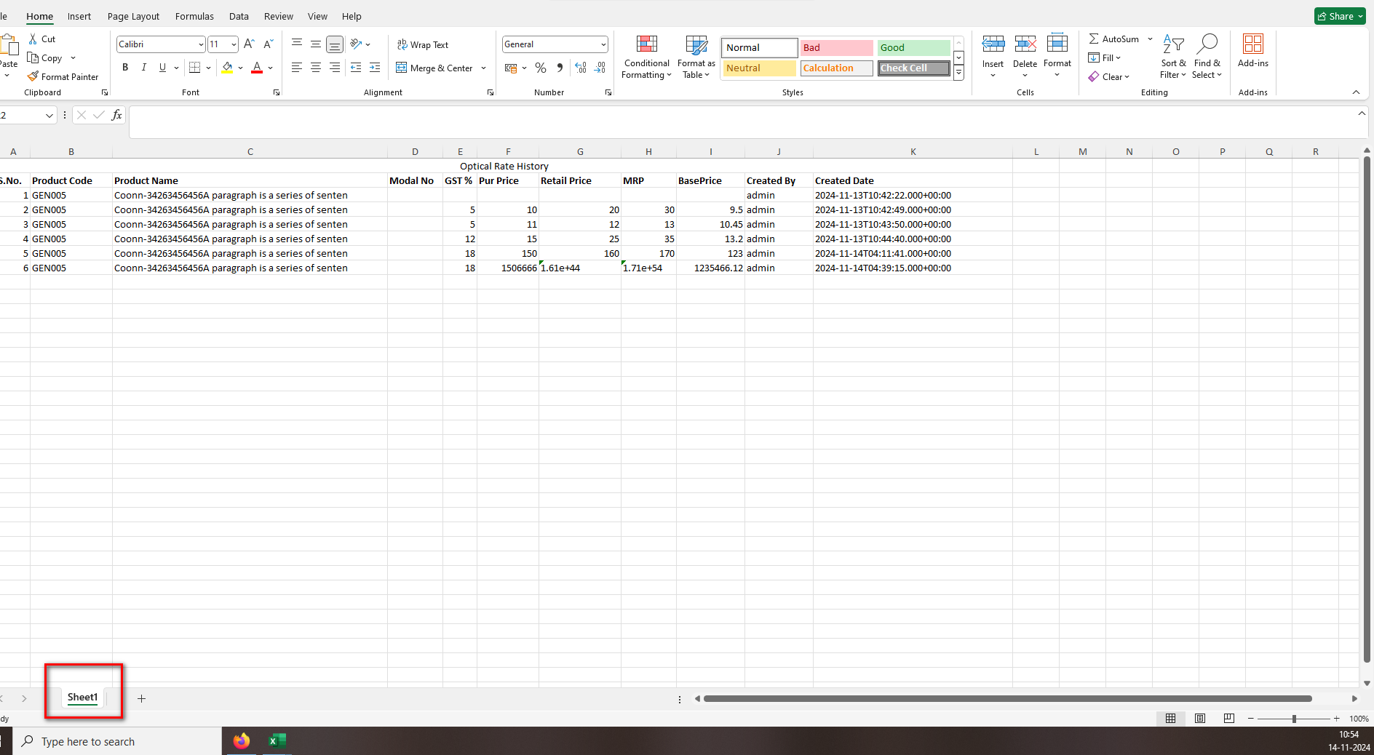 //
31. Placeholder/Inner Text not display in any field 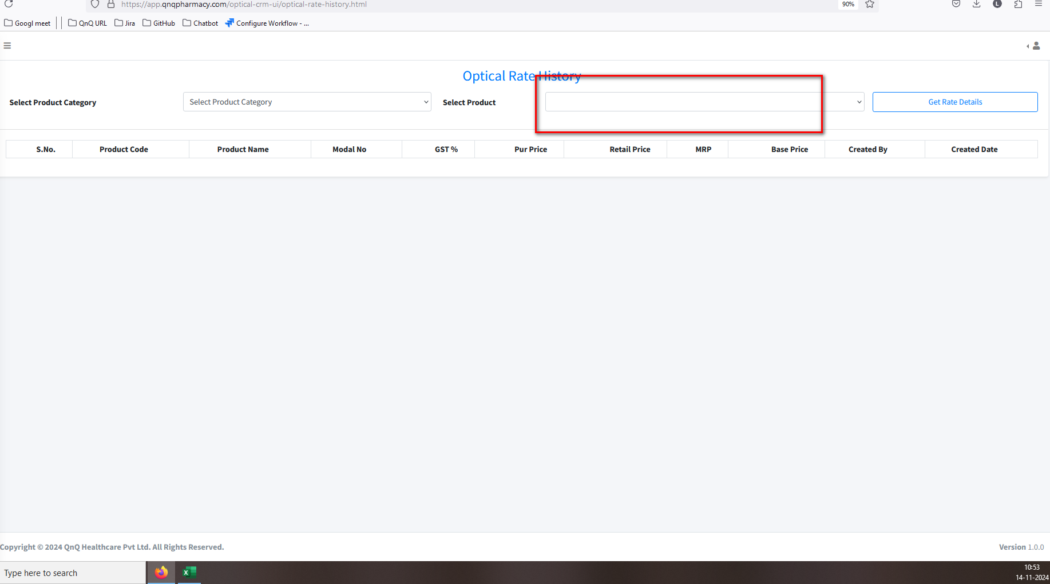 //
32. //